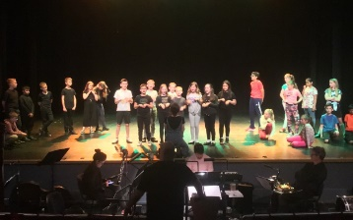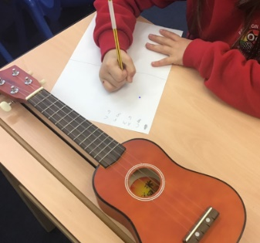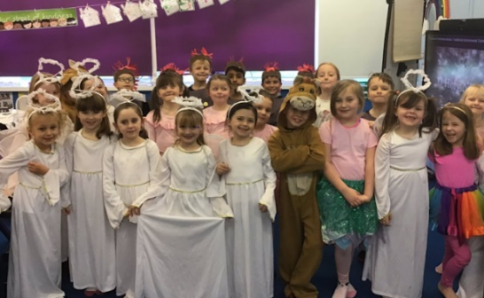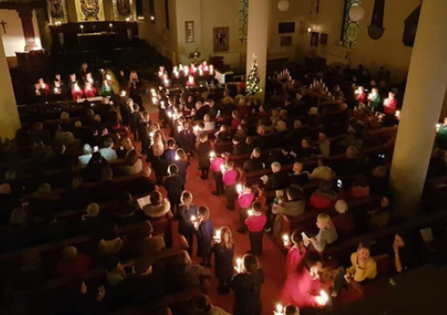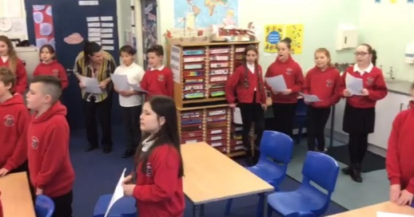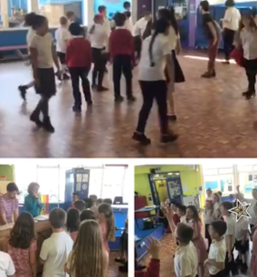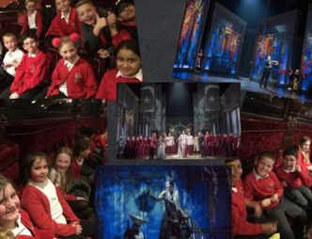

*The Key stage 1 Christmas play.*

*The ipad band at Whitley Bay Playhouse*

Last year also saw 2 new events for our school. The Year 5 ipad band made their debut at Whitley Bay Playhouse and Year 6 had fun playing their sambas in the Mouth of the Tyne parade.

*The Choir take part in the Christingle at Christchurch.*

*Attempting a 5 part harmony.*

*Year 5 practise their own opera to perform*

*Year 5 at the opera “The Magic Flute” by Mozart.*

**Music**

At Preston Grange we aim to develop the children’s ability to listen to, review and evaluate music across a range of historical periods, genres and cultures. They explore how music is created, looking at the structure and the different elements such as pitch, timbre, tempo and dynamics. The children have the opportunity to play both tuned and untuned instruments.

 We have regular singing assemblies and the children perform for the parents at Harvest Festival and Christmas shows. All children can choose to join the school choir which performs at many school and collaborative events including the North Shields Victorian Market, Party in the Park at the Rising Sun, Carol singing at Morrisons and the Christingle at Christchurch.

 We fully embrace Wider Opportunities. The recorder is learnt in Year 3 with ukulele being taught at the end of Year 4 and the beginning of Year 5. Ukulele lessons culminate in a performance at the end of the summer term.

